KAMPALA JUNIOR ACADEMY
HOLIDAY WORK SET FOUR TERM I 2020
PRIMARY SEVEN
INTEGRATED SCIENCE
Time allowed: 2 hours 15 minutes

Name: __________________________________________________________
School: _________________________________________________________
FOR EXAMINER’S USE ONLY
Read the following instructions carefully:
- The paper has two sections: A and B
- Section A has 40 questions (40 marks)
FOR EXAMINER’S USE
ONLY

Qn. No | MARK | SIGN
1 – 10
11 – 20
21 – 30
31 – 40
41 – 43
44 – 46
47 – 49
50 – 52
53 – 55
TOTAL

- Section B has 15 questions (60 marks)
- Answer ALL questions. All answers to both Sections A
and B must be written in the spaces provided.
- All answers must be written using a blue or black ball
point pen or ink. Diagrams should be drawn in pencil.
- Unnecessary crossing of work may lead to loss of marks.
- Any handwriting that cannot be easily read may lead to
loss of marks.
- Do not fill anything in the boxes indicated;
For Examiner’s use only.

Turn over

SECTION A
1. Name the gas which forms the greatest percentage of air in the atmosphere
___________________________________________________________
2. In which process can water be changed into water vapour?
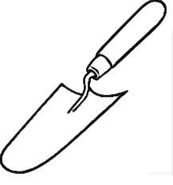
___________________________________________________________
3. Give any one characteristic that can help you distinguish between a hen and a cock.
___________________________________________________________
4. Give any one way in which ring worm is spread.
___________________________________________________________
5. Give the part of an insect that has the same function as the gills of a fish.
___________________________________________________________
6. How is the administration of measles vaccine similar to that of DPT vaccine?
___________________________________________________________
7. What is the effect of dehydration to a person?
___________________________________________________________
8. Give one danger of taking a wrong dose.
___________________________________________________________
9. Give one reason why uranium is grouped under non-renewable resources.
___________________________________________________________
10. Name any one viral cattle disease.
___________________________________________________________
The diagram below shows a garden tool. Use it to answer questions 11 and 12.

11. Name the tool shown above.
___________________________________________________________
12. Give one use of the tool to the farmer.
___________________________________________________________
13. Give one importance of echoes in the environment.
___________________________________________________________
14. Identify any one method used in harvesting rainwater.
___________________________________________________________
15. Give an enzyme which works on cooked starch.
___________________________________________________________
16. How is the blood carried by pulmonary artery different from that carried by the pulmonary vein?
___________________________________________________________
___________________________________________________________
17. Mention one method a farmer can use to control soil erosion in a hilly area.
___________________________________________________________
18. How are arachnids different from other arthropods?
___________________________________________________________
___________________________________________________________
The diagram below shows water being heated in a saucepan. Use it to answer questions 19 and 20.

19. What do the arrows in the water represent?
___________________________________________________________
20. How does heat reach the water?
___________________________________________________________
21. Give any one animal fibre found in the environment.
___________________________________________________________
22. How is a stretcher useful in giving First Aid?
___________________________________________________________
___________________________________________________________
23. How does painting a metal prevent it from rusting?
___________________________________________________________
24. What structures enable the absorption of food to take place in the small intestines?
___________________________________________________________
25. How can the school Health Committee tell whether a child is already immunized against Tuberculosis without referring to the Child Health Card?
___________________________________________________________
___________________________________________________________
26. Why is clay soil able to retain water much longer than the other types of soil?
___________________________________________________________
27. How does the breathing of an adult frog differ from that of a tadpole?
___________________________________________________________
28. What is a habitat?
___________________________________________________________
___________________________________________________________
29. How do animals benefit from photosynthesis?
___________________________________________________________
The diagram below shows a type of leaf. Use it to answer question 30.
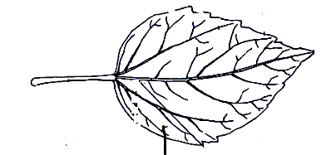

30. Name the type of compound leaf shown above.
___________________________________________________________
31. What form of energy does a falling tree have before it reaches the ground?
___________________________________________________________
32. Apart from the skin and lungs, name one other excretory organ.
___________________________________________________________
33. Give any one crop which is a legume.
___________________________________________________________
34. Give one reason why people who lift heavy loads need to feed on more carbohydrates.
___________________________________________________________
35. Why does a stone sink when it is put in a bucket full of water?
___________________________________________________________
36. Which bone in the human skeleton protects the brain?
___________________________________________________________
37. State the organisms that can be controlled by use of antibiotics.
___________________________________________________________
38. How does boiling of water help in the control of typhoid?
___________________________________________________________
39. Name the state of matter in which sound travels fastest.
___________________________________________________________
The diagram below shows part of a flower. Use it to answer question 40.

40. Name part marked Y.
___________________________________________________________

SECTION B (60 Marks)
41. Match the following weather instruments in A to their respective functions in list B.
A | B
Wind vane  Barometer  Rain gauge  Anemometer | measuring amount of rain.  measuring the speed of wind.  measuring the amount of air pressure.  measuring direction of wind.  measuring temperature.

(a) Wind vane __________________________________________________
(b) Barometer __________________________________________________
(c) Rain gauge _________________________________________________
(d) Anemometer ________________________________________________
42. Read the message below and answer the questions that follow.

NO SEX BEFORE MARRIAGE

(a) State two reasons why sex before marriage is bad.
(i) ___________________________________________________________
(ii) ___________________________________________________________
(b) Write PIASCY in full.
___________________________________________________________
___________________________________________________________
(c) State the best way of protecting yourself from getting sexually transmitted infections.
___________________________________________________________
43 (a) State one way in which a nursery bed is important to a farmer.
___________________________________________________________
(b) Name two vegetable crops commonly grown in a nursery bed.
(i) ___________________________________________________________
(ii) ___________________________________________________________
(c) Give one way in which a farmer can care for crops in a nursery bed.
___________________________________________________________
44. The diagram below shows a body organ. Use it to answer questions that follow.

X

Y
(a) Name the parts marked with letters X and Y.
(i) X ___________________________________________________________
(ii) Y ___________________________________________________________
(b) How is the organ above important to man?
___________________________________________________________
(c) Give one disease which affects the above organ.
___________________________________________________________
45 (a) What is a parasite?
___________________________________________________________
___________________________________________________________
(b) Mention any two ecto-parasites common on animal farms.
(i) ___________________________________________________________
(ii) ___________________________________________________________
(c) State any one way of controlling ecto-parasites on a cattle farm.
___________________________________________________________
46. Study the diagram of blood vessels below and answer questions that follow.
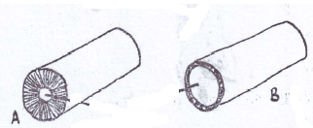

(a) Name the blood vessels marked A and B
(i) A ___________________________________________________________
(ii) B ___________________________________________________________
(b) State any one structural difference between blood vessels X and Y.
___________________________________________________________
___________________________________________________________
(c) Apart from the blood vessels, name any one component of the circulatory system.
___________________________________________________________

47 (a) Give one reason why we should breathe in through the nose.
___________________________________________________________
(b) Mention another name for the windpipe.
___________________________________________________________
(c) By what process does oxygen enter into the blood stream in the air sacs?
___________________________________________________________
(d) State any one disorder of the respiratory system.
___________________________________________________________
48. The diagram below shows one of the methods of grazing goats in Uganda. Use it to answer question 48.
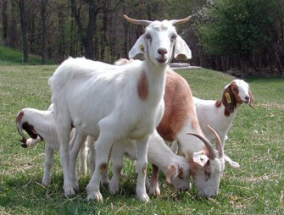

(a) Name the method of grazing goats shown in the diagram.
___________________________________________________________
(b) Give two advantages of using the method shown in the diagram.
(i) ___________________________________________________________
(ii) ___________________________________________________________
(c) Write down one disadvantage of using this method.
___________________________________________________________
___________________________________________________________
49. Okello ate posho, fish, cabbages and drank mango juice.
(a) What food value did Okello get from cabbages and mango juice?
___________________________________________________________
(b) If Okello had a wound on his skin, which of the above foods would help the wound to heal quickly?
___________________________________________________________
(c) Give any two reasons why most people do not eat balanced diet in Uganda.
(i) ___________________________________________________________
(ii) ___________________________________________________________
50 (a)Give one way in which industries pollute;
(i) the air: _____________________________________________________
___________________________________________________________
(ii) the water: __________________________________________________
___________________________________________________________
(b) State any two bad results of environmental pollution.
(i) ___________________________________________________________
(ii) ___________________________________________________________
51 (a) Mention any two examples of processed milk.
(i) ___________________________________________________________
(ii) ___________________________________________________________
(b) Give any two products from milk.
(i) ___________________________________________________________
(ii) ___________________________________________________________
52. The table below shows natural vegetative propagation. Complete it by filling in the missing words.
Plants | Method of propagation
Irish potatoes | ________________________
_______________________ | suckers
onion | ________________________
_______________________ | rhizomes

53. The diagram below is of a fish. Study it and answer the questions that follow.
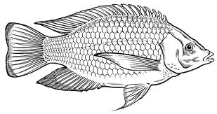
O

D

N L
(a) Name the structure marked L.
___________________________________________________________
(b) What is the function of each of the structures marked D and N?
(i) D ___________________________________________________________
(ii) N ___________________________________________________________
(c) Name the part marked O.
___________________________________________________________
54 (a) Give the meaning of each word below as used in sound.
(i) Frequency __________________________________________________
___________________________________________________________
(ii) Pitch ______________________________________________________
___________________________________________________________
(b) Mention any two factors which determine the pitch of sound.
(i) ___________________________________________________________
(ii) ___________________________________________________________
55 (a) Name the two types of pollination in flowering plants.
(i) ___________________________________________________________
(ii) ___________________________________________________________
(b) Write any two agents of pollination.
(i) ___________________________________________________________
(ii) ___________________________________________________________

Good Luck

